WEEK 1 PROJECT
Explore & Explain: How a Website Works
NAMES: Umutoni Hussina
Website: IGIRE Rwanda Organization
Action: Login
Learning Journal

1. Computing Foundations Check
When I open the IGIRE Rwanda website, my CPU works on the instructions needed to load the website and show it in my browser. RAM temporarily keeps the browser, website information, pictures and other things that the computer needs while I am using the website.

2. Digital Literacy Check
One thing I noticed is that the IGIRE Rwanda website uses HTTPS. This is important because it helps protect information when it is being sent between my browser and the website. Before entering personal information, I would check that I am on the real IGIRE Rwanda website and that the address starts with HTTPS. I would also check the privacy information to know how my information may be used.

3. Request and Response Walkthrough
I used Chrome Developer Tools and opened the Network tab. I selected the Doc filter and reloaded the IGIRE Rwanda website. I clicked on the main request and looked at the Headers section.
What I checked | What I found
Method | GET
URL | https://www.igirerwanda.org/
Status code | 200 OK
What it returned | The main webpage document (HTML) that the browser uses to display the page.
After I reload the website, the browser sends a request to the website. DNS can help find the server connected to the website name, and the request travels through the network to the server. The server receives the request and the backend can do the work needed to prepare the response. If information is needed, the backend can communicate with a database. Then the response is sent back to my browser and the browser displays the webpage. The 200 OK I saw means the request was successful.
In my screenshot, the request was shown as www.igirerwanda.org, with GET as the method, 200 OK as the status, and document as the type.

4. Frontend vs Backend Map
Item on the page | Frontend / Backend / Both | Reason
Page layout | Frontend | This is what the browser shows, such as where text and pictures are placed.
Navigation menu | Frontend | It is part of the page that I see and click.
Program information | Both | I see it on the page, but the information can be sent from the server.
Program cards | Both | The browser shows the cards, while their information can come from the website's data.
Login form | Both | The form is shown in the frontend, but the information entered has to be handled by the backend.
Images | Frontend | The browser loads and displays the pictures.
Login checking | Backend | The backend is responsible for processing the login information and checking the account.

5. System Diagram
I made this diagram to show my understanding of how a request can move when someone uses the IGIRE Rwanda website. It is a simple diagram for learning and does not mean I know the exact private setup of the organization's servers.
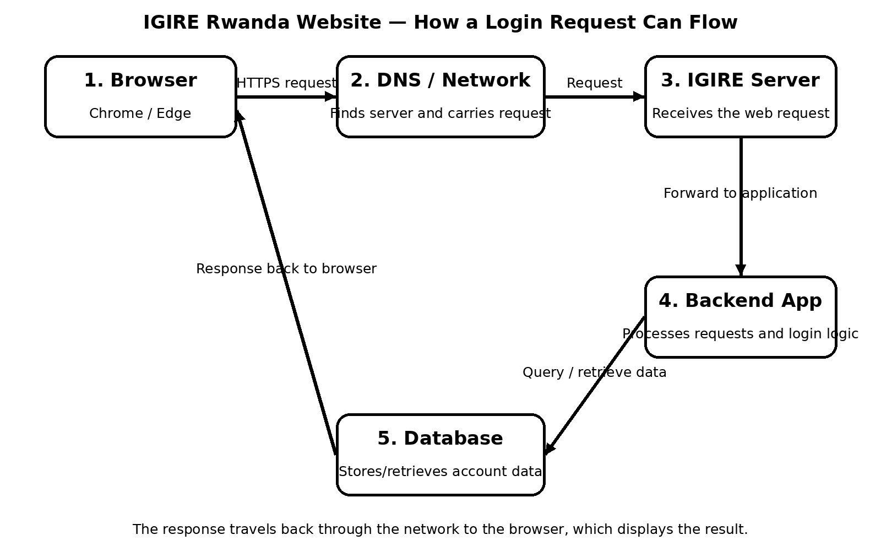

6. Algorithm: Login
- Open the IGIRE Rwanda website.
- Click the Login option.
- Enter the username or email.
- Enter the password.
- Click the Login button.
- The browser sends the login request to the server.
- The backend receives and processes the login information.
- The system checks the account information.
- If the information is correct, the user is allowed to log in.
- If the information is wrong, an error message is shown and the user can try again.

7. Reflection
The thing that surprised me most was how many things can happen when I click something on a website. Before doing this project, I mostly thought that when I open a website, the page just appears on my screen. After using the Network tab, I saw that the browser actually makes requests and receives responses. I also saw that there can be many requests when one page loads, for example for pictures, scripts and other files. I learned that the frontend and backend have different jobs. The frontend is mostly the part I can see and use, while the backend does work behind the website. For example, a login form is visible to me, but checking the login information is a backend job. The request I captured was a GET request to the IGIRE Rwanda website and it returned a 200 OK response, which helped me understand the request and response idea better. At the moment, I am leaning more towards Backend because I am interested in what happens behind the page. I would like to learn more about how requests are processed and how data is handled. I still understand that frontend is also important because it is what the user interacts with. This project helped me understand that a website is made of different parts that work together.

